Ideation Phase
Brainstorm & Idea Prioritization Template

Date | 25 September 2026
Team ID | 6ab2220abee0b08a2d2c65d0
Project Name | Auto Ticket Classification using Flow Designer
Maximum Marks | 4 Marks

Brainstorm & Idea Prioritization Template:
Brainstorming provides a free and open environment that encourages everyone within a team to participate in the creative thinking process that leads to problem solving. Prioritizing volume over value, out-of-the-box ideas are welcome and built upon, and all participants are encouraged to collaborate, helping each other develop a rich amount of creative solutions.
Use this template in your own brainstorming sessions so your team can unleash their imagination and start shaping concepts even if you're not sitting in the same room.
Reference: https://www.mural.co/templates/brainstorm-and-idea-prioritization
Step-1: Team Gathering, Collaboration and Select the Problem Statement
The team was assembled with 4 members: a ServiceNow Admin (Developer), a QA Tester, a Flow/UX Designer, and a Project Lead. After collaborative discussion, the team identified the core problem: IT helpdesks waste 20%+ of agent time manually categorizing tickets, while end-users struggle with complex dropdowns.
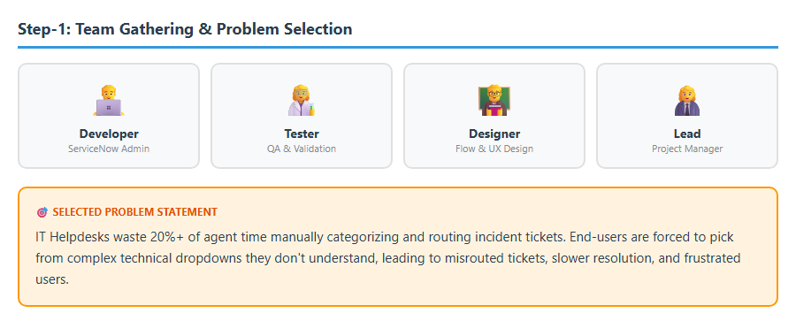
Step-2: Idea Generation (Brainstorming)
The team brainstormed 4 possible solutions: (1) Keyword-based auto-classification using Flow Designer, (2) ML-based Predictive Intelligence, (3) Manual Category dropdowns, and (4) Custom Chatbot triage. After evaluation, Idea 1 was selected for its low effort, high impact, and zero dependency on training data.
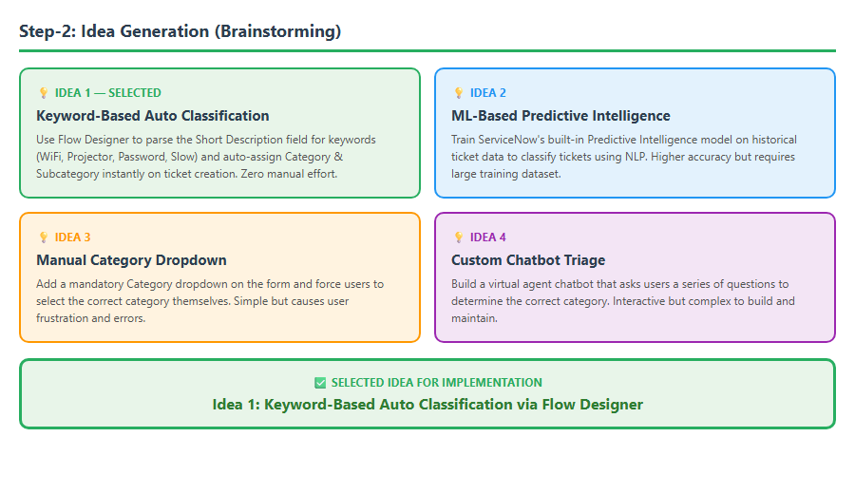

Step-3: Idea Prioritization
After generating all 4 ideas, the team evaluated each one using a 2x2 Impact vs Effort matrix. Each idea was plotted based on its implementation effort (Low to High) and its potential business impact (Low to High). The results are as follows:
• Quick Win (High Impact, Low Effort): Keyword-based Auto Classification via Flow Designer - SELECTED for implementation.
• Major Project (High Impact, High Effort): Full NLP/ML Model using Predictive Intelligence - planned as future upgrade.
• Fill-In (Low Impact, Low Effort): Manual Category dropdowns for users - rejected due to poor UX.
• Thankless Task (Low Impact, High Effort): Building a custom chatbot from scratch - rejected due to complexity.

Idea Prioritization Matrix:

